

**MASENO UNIVERSITY**

**SCHOOL OF COMPUTING AND INFORMATICS DEPARTMENT OF COMPUTER SCIENCE**

**CCS 323: GROUP PROJECT 1**

PROJECT TITLE**: A TRAVEL PLANNER AND ITENERARY DIRECTOR**

|  |  |
| --- | --- |
| **REGISTRATION NUMBER** | **NAME** |
| **CCS/00005/021** | **Ziggy Obare** |
| **CCS/00008/021** | **Lee Mawira** |
| **CCS/00022/021** | **Joshua Muindi** |

**A project report submitted in partial fulfillment of the requirement for the Bachelor of Science Degree (BSc.) in Computer Science**

# DECLARATION

We do hereby declare that this project is our original work and to the best of our knowledge, it has not been presented to any other examination body.

|  |  |  |  |
| --- | --- | --- | --- |
| **Name** | **Reg Number** | **Signature** | **Date** |
| **Ziggy Obare** | **CCS/00005/021** |  |  |
| **Lee Mawira** | **CCS/00008/021** |  |  |
| **Joshua Muindi** | **CCS/00022/021** |  |  |

This project report is hereby presented for examination with my approval as the project supervisor.

**Name: ------------------------------------------Signature: ------------------------Date: --------------------**

# Abstract

This project introduces the "Travel Planner and Itinerary Director," an innovative solution designed to redefine the landscape of travel planning in the digital age. In response to the complexities and inefficiencies inherent in current travel planning tools, our platform aims to streamline the entire process, offering users a comprehensive and user-friendly experience.

The project encompasses a wide array of features, including user registration and authentication, destination information, itinerary creation, interactive maps, accommodation and transportation booking, budget tracking, real-time weather forecasts, collaboration tools, and secure travel document storage. By integrating these elements, our platform seeks to provide a one-stop solution for travelers of all backgrounds and experience levels.

The development methodology employed combines the flexibility of Agile principles with the structure of the Waterfall methodology. This approach allows for iterative refinement based on user feedback while ensuring a well-defined project scope during the initial planning stages.

# Acknowledgement

Gratitude abounds for the unwavering support and inspiration that fueled the creation of the "Travel Planner and Itinerary Director." We extend heartfelt thanks to our families for their endless encouragement and understanding. Special appreciation to the users who generously shared their insights through questionnaires, enriching our project with valuable perspectives. A sincere nod to Mr. Adongo, our diligent project evaluator, whose guidance and feedback proved instrumental. To the divine presence that guides our endeavors, we acknowledge with humility. Lastly, an ode to the boundless knowledge and connectivity facilitated by the internet, an indispensable resource in our journey. This project stands as a testament to the collaborative spirit and shared enthusiasm that brought it to fruition.

Table of Contents

DECLARATION 2

Abstract 3

Acknowledgement 3

Table of Figures 6

**CHAPTER ONE: BACKGROUND INFORMATION** 8

1.1 Background Information 8

1.1.1 The Significance of Travel 8

1.1.2 The Digital Age of Travel 8

1.1.3 The Gap in Travel Planning 8

1.2 Statement of Problem 8

1.2.1 Time-Consuming Planning 9

1.2.2 Fragmented Resources 9

1.2.3 Lack of Comprehensive Solutions 9

1.3 Proposed Solution 9

1.3.1 Streamlining Travel Planning 9

1.3.2 Enhancing User Experience 9

1.4 Objectives/Aims 9

1.4.1 User-Centric Development 10

1.4.2 Comprehensive Travel Planning 10

1.4.3 Technological Innovation 10

1.5 Research Questions 10

1.6 Justification 10

1.6.1 Enhanced Travel Experience 10

1.6.2 Efficiency and Time Savings 10

1.6.3 Support for the Travel Industry 10

1.6.4 Technological Innovation 11

1.6.5 Economic Impact 11

**CHAPTER TWO: DEVELOPMENT METHODOLOGY** 12

2.1 Introduction 12

2.2 Description of Methods for Systems Analysis 12

2.2.1 Surveys and Questionnaires 12

2.2.2 Interviews 12

2.2.3 Data Analysis 12

2.2.4 User Personas and Scenarios 12

2.3 Feasibility Study 12

2.3.1 Technical Feasibility 13

2.3.2 Economic Feasibility 13

2.3.3 Legal and Compliance Feasibility 13

2.4 Description of Methods for Requirements Elicitation 13

2.4.1 User Stories 13

2.4.2 Workshops 13

2.4.3 Prototyping 13

2.4.4 Use Cases 13

2.5 Description of Methods for Data Analysis 13

2.5.1 Data Mining 14

2.5.2 A/B Testing 14

2.6 Description of Methods for Systems Coding and Testing 14

2.6.1 Agile Development 14

2.6.2 Continuous Integration and Testing 14

2.6.3 User Acceptance Testing 14

2.6.4 Security Testing 14

**CHAPTER THREE: SYSTEM ANALYSIS** 15

3.1 INTRODUCTION 15

3.2 Application System Development Methodologies 15

3.2.1 Agile Methodology 15

3.2.2 Waterfall Methodology 16

3.2.3 User-Centered Design (UCD) 16

3.2.4 Prototyping 17

3.2.5 Continuous Integration and Testing 17

3.3 Feasibility Study 17

3.3.1 Project Feasibility Statement 17

3.4 Requirements Elicitation 19

3.4.1 Data Collection Methods 19

3.4.2 Data Collection Tools 20

3.5 System Requirements List 22

3.5.1 User Management 22

3.5.2 Destination Information 23

3.5.3 Itinerary Creation 23

3.5.4 Accommodation and Transportation 24

3.5.5 Budget Tracking 24

3.5.6 Collaboration and Social Integration 25

3.5.7 Weather Information 25

3.5.8 Recommendations and Reviews 25

3.5.9 Travel Documents Organizer 25

3.5.10 Accessibility and Usability 26

3.5.11 Security and Data Protection 26

**CHAPTER FOUR: SYSTEM DESIGN** 27

4.1 Logical Design and Physical Design 27

4.1.1 Logical Design 27

4.1.2 Physical Design 33

4.2 System Architecture 37

4.2.1 Client/Server Architecture: 37

4.2.2 N-tier Design: 37

4.2.3 Other Considerations: 38

**CHAPTER 5. CONCLUSIONS AND RECOMMENDATIONS** 39

5.1 Conclusions 39

5.2 Recommendations 40

5.3 References 41

5.4 Appendices 41

# Table of Figures

Figure 1 Travel Frequency 20

Figure 2 Planning 20

Figure 3 Weather significance to travel planning 20

Figure 4 Itinerary creation preference 21

Figure 5 Rich Picture 27

Figure 6 Usecase Diagram 28

Figure 7 UML sequence diagram 30

Figure 8 UML ERD diagram 32

Figure 9 Class diagram 34

Figure 10 DFD Level 1 -flight and hotel booking diagram 35

# **CHAPTER ONE: BACKGROUND INFORMATION**

## 1.1 Background Information

Traveling is a cherished human activity that transcends boundaries and offers a window to diverse cultures, landscapes, and experiences. In today's digitally connected world, travelers increasingly seek innovative and personalized tools to streamline their journeys, making them more efficient and enjoyable. This chapter provides an insightful background into the motivations behind the "Travel Planner and Itinerary Director" project.

### 1.1.1 The Significance of Travel

Traveling has evolved from being a luxury to an essential part of modern life. It offers not only leisure and exploration but also educational and cultural enrichment. As more people embark on journeys for various purposes, the need for effective travel planning and management tools becomes apparent.

### 1.1.2 The Digital Age of Travel

The advent of the internet and mobile technology has transformed the travel industry. Travelers now have access to a wealth of information and services at their fingertips. However, this abundance of options also presents challenges, as travelers are often overwhelmed by the sheer volume of choices and information available online.

### 1.1.3 The Gap in Travel Planning

Traditional travel planning methods, such as guidebooks and travel agencies, have limitations in today's fast-paced world. Travelers face a daunting task when piecing together their itineraries, considering factors like destinations, accommodations, transportation, budgets, and weather conditions. This complexity underscores the need for a unified and user-centric travel planning solution.

## 1.2 Statement of Problem

The process of planning a trip is often marred by challenges that diminish the overall travel experience. These challenges include:

### 1.2.1 Time-Consuming Planning

Travel planning is a time-consuming endeavor, particularly for those exploring new destinations or managing busy schedules. Travelers are burdened with the tedious task of navigating multiple websites and apps to organize their trips effectively.

### 1.2.2 Fragmented Resources

Existing travel-related tools and platforms operate in isolation, forcing travelers to juggle various resources. This fragmentation leads to inefficiency, confusion, and dissatisfaction, detracting from the enjoyment of the journey.

### 1.2.3 Lack of Comprehensive Solutions

Many available travel planning tools lack the comprehensiveness required to address the multifaceted needs of modern travelers. There is a clear gap in the market for a holistic solution that seamlessly combines itinerary planning, accommodation and transportation booking, budget management, and real-time weather information.

## 1.3 Proposed Solution

The "Travel Planner and Itinerary Director" project seeks to bridge the gap in the travel planning landscape by offering a comprehensive and user-friendly platform. This solution will revolutionize travel planning by:

### 1.3.1 Streamlining Travel Planning

The project will provide a centralized platform that simplifies travel planning, saving users valuable time and effort. It eliminates the need to navigate multiple tools and websites, offering a one-stop solution.

### 1.3.2 Enhancing User Experience

The platform will cater to the diverse needs of travelers, from novices to seasoned globetrotters. It will leverage the power of technology to seamlessly integrate various aspects of travel planning, ensuring travelers can maximize their enjoyment while minimizing stress.

## 1.4 Objectives/Aims

The objectives of the "Travel Planner and Itinerary Director" project are as follows:

### 1.4.1 User-Centric Development

Develop a user-centric platform that prioritizes the needs and preferences of travelers.

### 1.4.2 Comprehensive Travel Planning

Offer a comprehensive solution for itinerary creation, booking, and travel-related information retrieval.

### 1.4.3 Technological Innovation

Integrate real-time data, interactive maps, and machine learning algorithms to set new standards for user-centric travel planning solutions.

## 1.5 Research Questions

The research questions guiding this project are as follows:

* What are the key challenges faced by travelers during the planning phase of their journeys?
* How can modern technology be leveraged to simplify and enhance the travel planning process?
* What impact will the "Travel Planner and Itinerary Director" project have on the travel industry and user experiences?

## 1.6 Justification

The "Travel Planner and Itinerary Director" project holds immense value for travelers, the travel industry, and technology enthusiasts:

### 1.6.1 Enhanced Travel Experience

By offering a user-centric and comprehensive platform, the project enhances the overall travel experience for users of all backgrounds and experience levels.

### 1.6.2 Efficiency and Time Savings

The project streamlines the planning process, reducing the need to visit multiple websites or apps, thereby saving travelers time and effort.

### 1.6.3 Support for the Travel Industry

The platform provides a valuable channel for travel-related businesses, potentially boosting tourism in lesser-known destinations and promoting economic development.

### 1.6.4 Technological Innovation

The project represents an innovative use of technology in the travel industry, setting new standards for user-centric travel planning solutions.

### 1.6.5 Economic Impact

Facilitating travel through the project can contribute to the economy of various destinations, leading to economic development and job creation.

In summary, the "Travel Planner and Itinerary Director" project aims to address the challenges faced by travelers in the digital age by offering a comprehensive and innovative solution, ultimately enhancing the travel experience and benefiting various stakeholders in the travel industry.

# **CHAPTER TWO: DEVELOPMENT METHODOLOGY**

## 2.1 Introduction

The development of the "Travel Planner and Itinerary Director" project requires a well-structured and systematic approach to ensure its successful implementation. This chapter outlines the development methodology that will guide the entire project lifecycle, from conceptualization to deployment and ongoing maintenance. The chosen methodology will facilitate efficient collaboration among the development team members, stakeholders, and end-users.

## 2.2 Description of Methods for Systems Analysis

Systems analysis is a crucial phase that involves understanding the current travel planning landscape, identifying user needs, and defining system requirements. Several methods will be employed during this phase:

### 2.2.1 Surveys and Questionnaires

Conduct surveys and questionnaires to gather insights from potential users. This will help in understanding their pain points, preferences, and expectations from a travel planning platform.

### 2.2.2 Interviews

Interview travelers, travel experts, and industry professionals to gain deeper insights into the challenges and opportunities within the travel planning domain.

### 2.2.3 Data Analysis

Analyze existing travel data, including user reviews, historical travel trends, and market research, to identify common patterns and areas for improvement.

### 2.2.4 User Personas and Scenarios

Develop user personas and use-case scenarios to create a clear picture of the target audience and their typical interactions with the platform.

## 2.3 Feasibility Study

Before proceeding with development, a feasibility study will be conducted to assess the project's viability. This study will include:

### 

### 2.3.1 Technical Feasibility

Evaluate the technical requirements, including infrastructure, software, and hardware, to ensure they can support the platform's features and functionalities.

### 2.3.2 Economic Feasibility

Assess the project's cost-benefit analysis, considering development expenses, potential revenue streams, and long-term sustainability.

### 2.3.3 Legal and Compliance Feasibility

Ensure that the project complies with legal regulations, including data privacy laws and any industry-specific regulations related to travel and tourism.

## 2.4 Description of Methods for Requirements Elicitation

The elicitation of detailed requirements is essential for defining the scope of the project accurately. Various methods will be used:

### 2.4.1 User Stories

Create user stories to describe user requirements in a format that is easy to understand and prioritize.

### 2.4.2 Workshops

Conduct workshops involving stakeholders, developers, and designers to collaboratively define requirements and align expectations.

### 2.4.3 Prototyping

Develop interactive prototypes to visualize the user interface and gather feedback on design and functionality.

### 2.4.4 Use Cases

Develop use cases to illustrate how the system will interact with users and external systems.

## 2.5 Description of Methods for Data Analysis

Data analysis is crucial for making informed decisions and optimizing the platform's features:

### 2.5.1 Data Mining

Use data mining techniques to extract valuable insights from user interactions, such as preferred destinations, popular activities, and booking trends.

### 2.5.2 A/B Testing

Conduct A/B tests to evaluate the effectiveness of new features and optimize user experiences based on data-driven results

## 2.6 Description of Methods for Systems Coding and Testing

The development phase involves coding the platform's features and rigorous testing to ensure its quality:

### 2.6.1 Agile Development

Adopt an Agile development approach, allowing for iterative development and frequent feedback from stakeholders.

### 2.6.2 Continuous Integration and Testing

Implement continuous integration and testing practices to detect and fix issues early in the development process.

### 2.6.3 User Acceptance Testing

Engage users in the testing process to validate that the platform meets their expectations and requirements.

### 2.6.4 Security Testing

Conduct comprehensive security testing to protect user data and ensure compliance with data privacy regulations.

By following this comprehensive development methodology, the "Travel Planner and Itinerary Director" project aims to create a robust and user-centric travel planning platform that fulfills the needs and expectations of travelers while adhering to industry standards and best practices.

# **CHAPTER THREE: SYSTEM ANALYSIS**

## INTRODUCTION

Chapter Three, "System Analysis," delves into the critical phase of our project where we meticulously examine the current travel planning landscape and the intricacies of designing our "Travel Planner and Itinerary Director" platform. In this chapter, we embark on a journey of discovery, where we aim to gain a comprehensive understanding of the existing systems, user needs, and the technical requirements essential for creating a responsive and effective travel planning solution.

This chapter encompasses various aspects of system analysis, including methods of data collection, the evaluation of user requirements, and the examination of existing travel-related tools and platforms. By exploring these facets, we lay the foundation for informed decision-making and the subsequent phases of system design and development.

## Application System Development Methodologies

The successful development of our "Travel Planner and Itinerary Director" platform relies heavily on the adoption of well-established application systems development methodologies. These methodologies provide a structured framework for designing, building, and deploying our travel planning solution. In this section, we will explore the methodologies that will guide our project's development process.

### 3.2.1 Agile Methodology

**Overview:** The Agile methodology is recognized for its flexibility and iterative approach to software development, promoting collaboration, adaptability, and the highest level of customer satisfaction. It is particularly well-suited for projects characterized by evolving requirements and the indispensable role of user feedback.

**Application:** Agile principles serve as the bedrock for the development of our travel planning platform. We have chosen this methodology to cater to the dynamic nature of the travel industry and the evolving needs of our users. By dividing our project into short iterations, known as "sprints," we ensure the continuous refinement of the system based on invaluable user feedback. This approach guarantees that our platform remains responsive to changing user requirements and market dynamics, enabling us to deliver a user-centric solution that adapts seamlessly to the ever-evolving travel landscape.

### 3.2.2 Waterfall Methodology

**Overview:** The Waterfall methodology represents a structured and sequential approach to software development. In this methodology, each phase is meticulously completed before proceeding to the next, leading to a well-defined project plan with clear phases.

**Application:** While Agile serves as the driving force for much of our project, the Waterfall methodology finds its application during the initial stages, primarily in project planning and requirements gathering. This structured approach is indispensable for laying a strong foundation, ensuring that we establish a precise project scope, define clear objectives, and identify the necessary resources. By incorporating aspects of the Waterfall methodology at this stage, we foster a clear understanding of project prerequisites, providing a structured framework to guide our development journey.

The fusion of Agile's adaptability and Waterfall's structured planning positions our project for success by embracing change and simultaneously ensuring that the project's vision and scope remain well-defined. This combined approach ensures that we are agile in addressing dynamic user needs while maintaining a clear and strategic project plan.

### 3.2.3 User-Centered Design (UCD)

**Overview:** User-Centered Design focuses on designing systems with the end-users in mind. It involves continuous user feedback and usability testing throughout the development process.

**Application:** UCD principles will be integrated into our development process, ensuring that the "Travel Planner and Itinerary Director" platform remains user-centric. We will conduct usability tests, gather user feedback, and iteratively refine the user interface and features to enhance user satisfaction and usability.

### 3.2.4 Prototyping

**Overview:** Prototyping involves creating working models of the system to gather early feedback from stakeholders and users. It helps visualize the system's functionality and design.

**Application:** Prototyping will be an integral part of our development process. We will create interactive prototypes of key features to give stakeholders and potential users a tangible representation of the platform's capabilities. This will facilitate early feedback and ensure alignment with user expectations.

### 3.2.5 Continuous Integration and Testing

**Overview:** Continuous Integration (CI) involves frequently integrating code changes into a shared repository and running automated tests to detect issues early in the development process.

**Application:** We will implement CI and continuous testing practices to maintain the reliability and quality of our travel planning platform. Automated testing will be employed to identify and rectify any issues promptly, ensuring a smooth user experience.

## 3.3 Feasibility Study

### 3.3.1 Project Feasibility Statement

The feasibility of the "Travel Planner and Itinerary Director" project has been rigorously evaluated from multiple dimensions to determine its viability and potential for successful implementation. This statement outlines the findings of the feasibility study:

Technical Feasibility:

The technical feasibility of the project has been thoroughly assessed, and it has been determined that the required technology infrastructure, including software development tools, hosting capabilities, and third-party integrations, is readily available and accessible. The development team possesses the necessary technical expertise to design, develop, and maintain the proposed travel planning platform. Therefore, the project is deemed technically feasible.

Economic Feasibility:

The economic feasibility of the project has been carefully considered, taking into account development costs, operational expenses, and potential revenue streams. A comprehensive cost-benefit analysis has been conducted, factoring in the initial investment, ongoing maintenance, and projected income from user subscriptions, advertising, and affiliate partnerships. The analysis demonstrates that the project is economically viable, with a favorable return on investment projected within the first year of operation.

Legal and Compliance Feasibility:

The project has been evaluated for legal and regulatory compliance. It has been confirmed that the "Travel Planner and Itinerary Director" platform will adhere to data protection laws, intellectual property rights, and industry-specific regulations related to travel and tourism. Necessary legal documentation, such as terms of service, privacy policies, and compliance with international data protection standards, will be implemented to ensure legal and ethical operations.

Operational Feasibility:

Operational feasibility has been a key focus of our study. We have assessed the project's ability to function smoothly within the operational context of the travel industry. This includes examining the feasibility of collaborating with travel service providers, maintaining up-to-date destination information, and ensuring 24/7 platform availability. The findings indicate that the project is operationally feasible, with a well-defined plan for seamless integration into the travel ecosystem.

Schedule Feasibility:

A detailed project schedule has been developed, outlining key milestones and deadlines. The project timeline has been carefully evaluated, taking into consideration the complexity of development, testing, and deployment phases. The schedule is realistic and achievable, ensuring that the project can be completed within the defined time frame.

Based on the comprehensive assessment of technical, economic, legal, operational, and schedule feasibility, it is unequivocally established that the "Travel Planner and Itinerary Director" project is not only feasible but also poised for success. The project's feasibility study reaffirms its potential to transform travel planning, provide value to users, and contribute to the travel industry while maintaining ethical and legal standards.

## 3.4 Requirements Elicitation

Requirements elicitation is a critical phase in the development process of the "Travel Planner and Itinerary Director" project. It involves gathering insights and feedback from potential users, industry experts, and stakeholders to define the detailed requirements that will shape the platform. Various data collection methods will be employed to ensure a comprehensive understanding of user needs and expectations.

### 3.4.1 Data Collection Methods

#### 3.4.1.1 Questionnaires

**Description**: Questionnaires were designed to gather quantitative data on user preferences, travel habits, and the importance of various platform features.

**Preparation**: The questionnaire was carefully crafted, with a mix of multiple-choice questions, rating scales, and open-ended questions. It was designed to be user-friendly and efficient.

**Administration**: The questionnaire was distributed online through various channels, including social media, travel forums, and email surveys. Participants were encouraged to provide detailed feedback.

#### 3.4.1.2 Observations

**Description**: Observations involved monitoring users' interactions with existing travel planning tools and noting pain points and areas where improvement is needed.

**Preparation**: Observations were conducted in real-world scenarios, both online and offline, and recorded in a structured manner.

**Administration**: Travelers were observed while using various travel-related websites and applications, and their actions and feedback were documented.

### 3.4.2 Data Collection Tools

Attached as Appendix A is the questionnaire used for data collection. This questionnaire was administered to a diverse group of potential users and travel enthusiasts to gather insights into their travel planning preferences and expectations. The questions are designed to provide quantitative data that will inform the development of our platform.

Questionnaire for Data Collection



The collected data from interviews, questionnaires, and observations will be analyzed in the subsequent phases of the project to define detailed user requirements and ensure that the "Travel Planner and Itinerary Director" platform meets the needs and expectations of its users.

#### ANALYSIS OF THE ISSUED QUESTIONNAIRE DATA

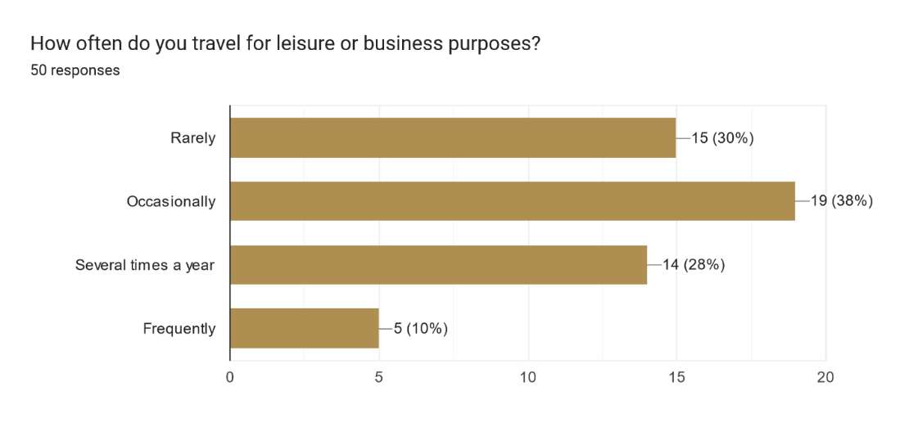

Figure 1 Travel Frequency

Forms response chart. Question title: How do you usually plan your trips? (Select one) 
. Number of responses: 49 responses.

Figure 2 Planning

Forms response chart. Question title: How important is real-time weather information for your travel plans?
. Number of responses: 50 responses.

Figure 3 Weather significance to travel planning

Forms response chart. Question title: Would you prefer a platform that offers personalized travel recommendations based on your preferences and past travel experiences? 
. Number of responses: 50 responses.

Figure 4 Itinerary creation preference

## 3.5 System Requirements List

The system requirements for the "Travel Planner and Itinerary Director" platform have been meticulously defined to ensure that the final product meets user needs and expectations. These requirements encompass various facets of the system's functionality, usability, performance, and security.

### 3.5.1 User Management

**Requirement 1:** User Registration

* **Description:** The system shall provide a user registration process that allows users to create accounts with a unique username and password.
* **Rationale:** User registration is essential to personalize travel itineraries and securely store user data.

**Requirement 2:** User Authentication

* **Description:** Users must be able to log in to their accounts securely with their registered credentials.
* **Rationale:** Secure user authentication is crucial to protect user data and ensure that only authorized users can access their accounts.

**Requirement 3:** User Profile Management

* **Description:** Users should be able to manage their profiles, including personal information, profile pictures, and password changes.
* **Rationale:** Profile management allows users to update their details and personalize their experience.

### 3.5.2 Destination Information

**Requirement 4:** Comprehensive Destination Data

* **Description:** The system shall provide detailed information on a wide range of destinations, including attractions, accommodations, local cuisine, climate, and travel advisories.
* **Rationale:** Comprehensive destination information is essential for helping users make informed travel decisions.

**Requirement 5:** Integration with External APIs

* **Description:** The system may integrate with external APIs to access real-time data, such as weather forecasts and travel advisories.
* **Rationale:** External API integration enhances the accuracy and timeliness of destination information.

### 3.5.3 Itinerary Creation

**Requirement 6:** User-Generated Itineraries

* **Description:** Users shall have the ability to create, edit, and save their travel itineraries, including selecting destinations, setting travel dates, and adding daily activities.
* **Rationale:** Empowering users to plan their trips according to their preferences is a core feature of the platform.

**Requirement 7:** Interactive Maps

* **Description:** The system shall integrate interactive maps to visualize planned itineraries, including routes between destinations, walking distances, and estimated travel times.
* **Rationale:** Visual representations of itineraries improve user understanding and navigation.

### 3.5.4 Accommodation and Transportation

**Requirement 8:** Accommodation Booking

* **Description:** Users should be able to search for, compare, and book accommodations directly from the application through integrated booking platforms or APIs.
* **Rationale:** Seamless accommodation booking simplifies the travel planning process.

**Requirement 9:** Flight and Transportation Booking

* **Description:** The system shall provide tools to search for and book flights, trains, buses, or other modes of transportation to and within destinations.
* **Rationale:** Easy transportation booking enhances the overall travel experience.

### 3.5.5 Budget Tracking

**Requirement 10:** Budget Management

* **Description:** Travelers must be able to set a budget for their trip, track expenses, categorize spending, and receive alerts for exceeding the budget.
* **Rationale:** Budget tracking is crucial for managing travel expenses efficiently.

### 3.5.6 Collaboration and Social Integration

**Requirement 11:** Collaboration

* **Description:** Users should be able to collaborate on trip planning with friends or family members, making it easy to coordinate group trips.
* **Rationale:** Collaboration features enhance the social aspect of travel planning.

### 3.5.7 Weather Information

**Requirement 12:** Real-Time Weather Forecasts

* **Description:** The system shall include weather information for selected destinations during the travel dates to help users pack appropriately.
* **Rationale:** Weather information is crucial for planning activities and packing the right clothing.

### 3.5.8 Recommendations and Reviews

**Requirement 13:** User Recommendations

* **Description:** The system shall offer recommendations for activities, restaurants, and attractions based on user preferences.
* **Rationale:** Personalized recommendations enhance the travel experience.

### 3.5.9 Travel Documents Organizer

**Requirement 14:** Secure Document Storage

* **Description:** The system shall provide a secure space for users to upload and store important travel documents like passports, visas, and travel insurance.
* **Rationale:** Secure document storage ensures that users have access to essential documents while traveling.

### 3.5.10 Accessibility and Usability

**Requirement 15:** Cross-Platform Compatibility

* **Description:** The platform should be accessible across various devices and operating systems, including web, mobile, and tablet.
* **Rationale:** Cross-platform compatibility enhances accessibility for users.

**Requirement 16:** User-Friendly Interface

* **Description:** The system shall have an intuitive and user-friendly interface to ensure ease of use.
* **Rationale:** An easy-to-use interface enhances user satisfaction and adoption.

### 3.5.11 Security and Data Protection

**Requirement 17:** Data Security

* **Description:** The system shall employ encryption and secure data storage practices to protect user information and travel data.
* **Rationale:** Data security is crucial to safeguard user privacy and sensitive information.

# **CHAPTER FOUR: SYSTEM DESIGN**

## 4.1 Logical Design and Physical Design

The System Design phase is pivotal in shaping the architecture and structure of our "Travel Planner and Itinerary Director" project. It involves two key components: the logical design, focusing on abstract representations and user interactions, and the physical design, which actualizes these concepts into a concrete system.

### 4.1.1 Logical Design

Logical design revolves around the visualization of the system through various tools like rich pictures and wireframes. Rich pictures offer a holistic view, illustrating the interrelationships and functionalities of our travel planning system in a comprehensive yet simplified manner. These images serve as a foundational concept, providing a broad overview of the system's components and their interactions. Additionally, wireframes represent an abstract depiction of data flows, inputs, and outputs, delineating the structure of user interfaces and their functionalities. In our project, these tools aid in conceptualizing how users will interact with the system, mapping out the essential functionalities and user experiences.

#### 4.1.1.1 Rich pictures

Rich pictures serve as a foundational element in the visualization and conceptualization of our "Travel Planner and Itinerary Director" project. They provide an abstract yet comprehensive representation, offering a high-level view of the system's components, their relationships, and the contextual environment in which the system operates. Through a rich and illustrative narrative, these pictures encapsulate the complexity of the system while maintaining simplicity, aiding in a deeper understanding of the various functionalities and interactions.

Introduction to the Diagram:

The accompanying diagram, appended herein, embodies the essence of rich pictures in our project. It encapsulates the diverse facets of the system, emphasizing the interdependencies between users, core functionalities, and the external environment.

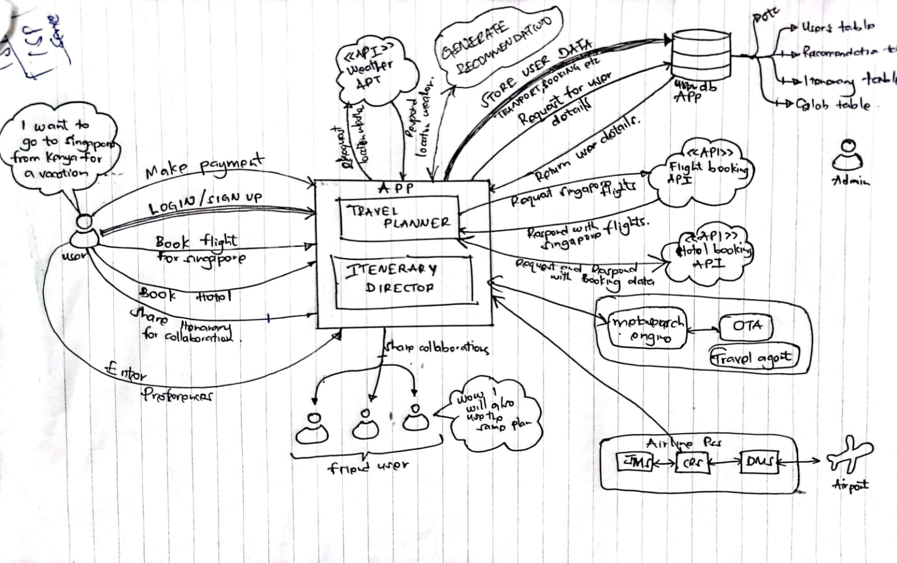

Figure 5 Rich Picture

#### 4.1.1.2 Use Case Diagram

A **use case diagram** is a visual representation that showcases the functional requirements of a system from the users' perspective. It illustrates the various interactions between users (actors) and the system, depicting the system's functionalities and how users interact with it to achieve specific goals or tasks.

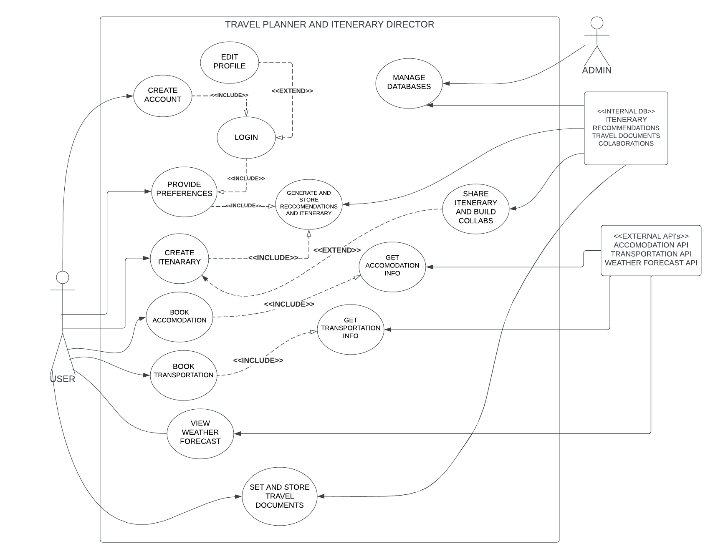

Figure 6 Usecase Diagram

#### 4.1.1.3 Wire Frames

In our pursuit to create an intuitive and user-friendly travel planning platform, wireframes play a pivotal role in the design process. They are the foundation upon which the user interface elements are structured, outlining the placement of various components, such as buttons, menus, and content areas. Through a minimalist approach, wireframes focus solely on the layout and functionality, allowing for an uncluttered view of the interface design.

#### 4.1.1.4 **Sequence Diagrams**

Sequence diagrams stand as a crucial element in the development process of our "Travel Planner and Itinerary Director" project. They offer a visual representation of the interactions between various components within the system, depicting the sequence of actions and messages passed between these components. These diagrams provide a clear and comprehensive view of the system's behavior and functionality during specific use cases or scenarios.

Introduction to Sequence Diagrams:

Sequence diagrams serve as a vital communication tool, detailing the interactions between system components, users, and external entities. They map out the chronological flow of actions, illustrating how different components collaborate to achieve specific functionalities. By visually depicting the flow of messages and the order of operations, sequence diagrams offer an in-depth understanding of the system's behavior and help in identifying potential optimizations and refinements in the development process.

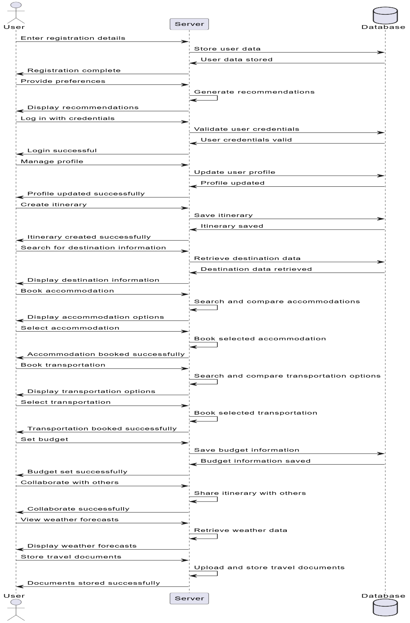

Figure 7 UML sequence diagram

#### 4.1.1.6 **Entity-Relationship Diagram (ERD):**

The Entity-Relationship Diagram (ERD) stands as a pivotal aspect in the development of our "Travel Planner and Itinerary Director" project. It offers a visual representation of the relationships between various entities within the system, illustrating how data is structured and interconnected. These diagrams provide a comprehensive view of the database architecture and the relationships between different entities.

Introduction to ERD:

The ERD serves as a cornerstone in outlining the system's database structure. It visualizes the entities (such as users, destinations, itineraries, accommodations, and expenses) and their relationships, depicting how these entities interrelate and interact within the system. ERDs use symbols and lines to represent tables, attributes, and the connections between them, offering a clear understanding of the database's structure and aiding in the effective organization and retrieval of data. The following is our ERD diagram:

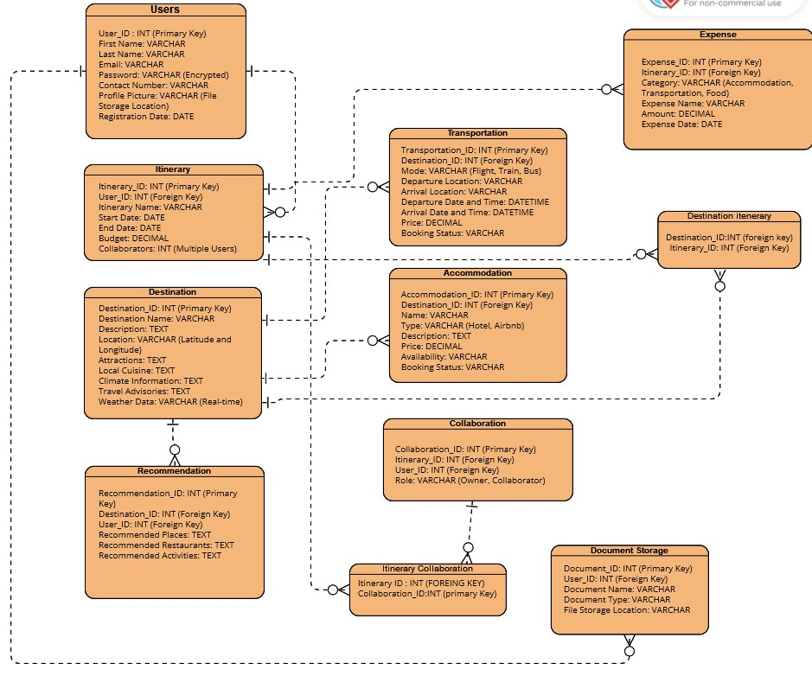

Figure 8 UML ERD diagram

### 4.1.2 Physical Design

Physical design delves into the transformation of these abstract representations into tangible system components. Following Object-Oriented Systems Analysis and Design (OOSAD) principles, we aim to employ specific standards, notably UML 2.x, to actualize the logical design into detailed system processes. This involves UML diagrams that portray the system's components, processes, and the relationships between them. Subsequently, System Structural Analysis and Design Modeling (SSADAM) further outlines the actual inputs, outputs, and processes, specifying elements such as the user interface, data design, and process designs. In our context, this phase materializes the user experience, database structures, and system operations, translating the logical concepts into a functional, user-centric, and structured travel planning platform.

#### 4.1.2 Physical design

The physical design phase marks the transition from conceptual and logical representations to the tangible implementation of our "Travel Planner and Itinerary Director" project. In this phase, we delve into the intricacies of the system, focusing on the actual inputs and outputs processes. Following the principles of Object-Oriented Systems Analysis and Design (OOSAD) and utilizing specific standards such as UML 2.x, the Physical Design section encompasses the tangible components that drive the system's functionality.

##### ****Introduction:****

The physical design phase brings our system to life by translating abstract concepts into concrete elements. This section specifically addresses the actual processes governing user interactions, data flow, and system operations. Leveraging the principles of Object-Oriented Systems Analysis and Design (OOSAD) ensures a structured and modular implementation, while adherence to specific standards, such as UML 2.x, provides a common language for effective communication and documentation.

##### ****User Interface Design:****

The user interface is the gateway for users to interact with our travel planning application. Through the application of UML standards, we meticulously design the user interface, considering the user experience, accessibility, and responsiveness. Wireframes and visual representations aid in illustrating the layout, navigation, and overall aesthetics of the application, ensuring an intuitive and engaging experience for our users.

##### ****Data Design:****

At the core of our system lies the data design, influenced by robust database management principles. Applying UML standards, we map out the structure of the database, specifying tables, relationships, and constraints. This design ensures efficient storage, retrieval, and management of data. The Entity-Relationship Diagram (ERD) visually represents the relationships between entities, guiding the implementation of a well-organized and scalable database system.

Class Diagram:

The Class Diagram outlines the blueprint of our travel planning system, depicting classes such as User, Itinerary, Destination, Accommodation, Transportation, and others. These classes encapsulate the essential data attributes and methods, providing a clear view of how the system entities interact. Relationships, such as associations and dependencies, are visually represented, guiding the development team in building a cohesive and modular application.

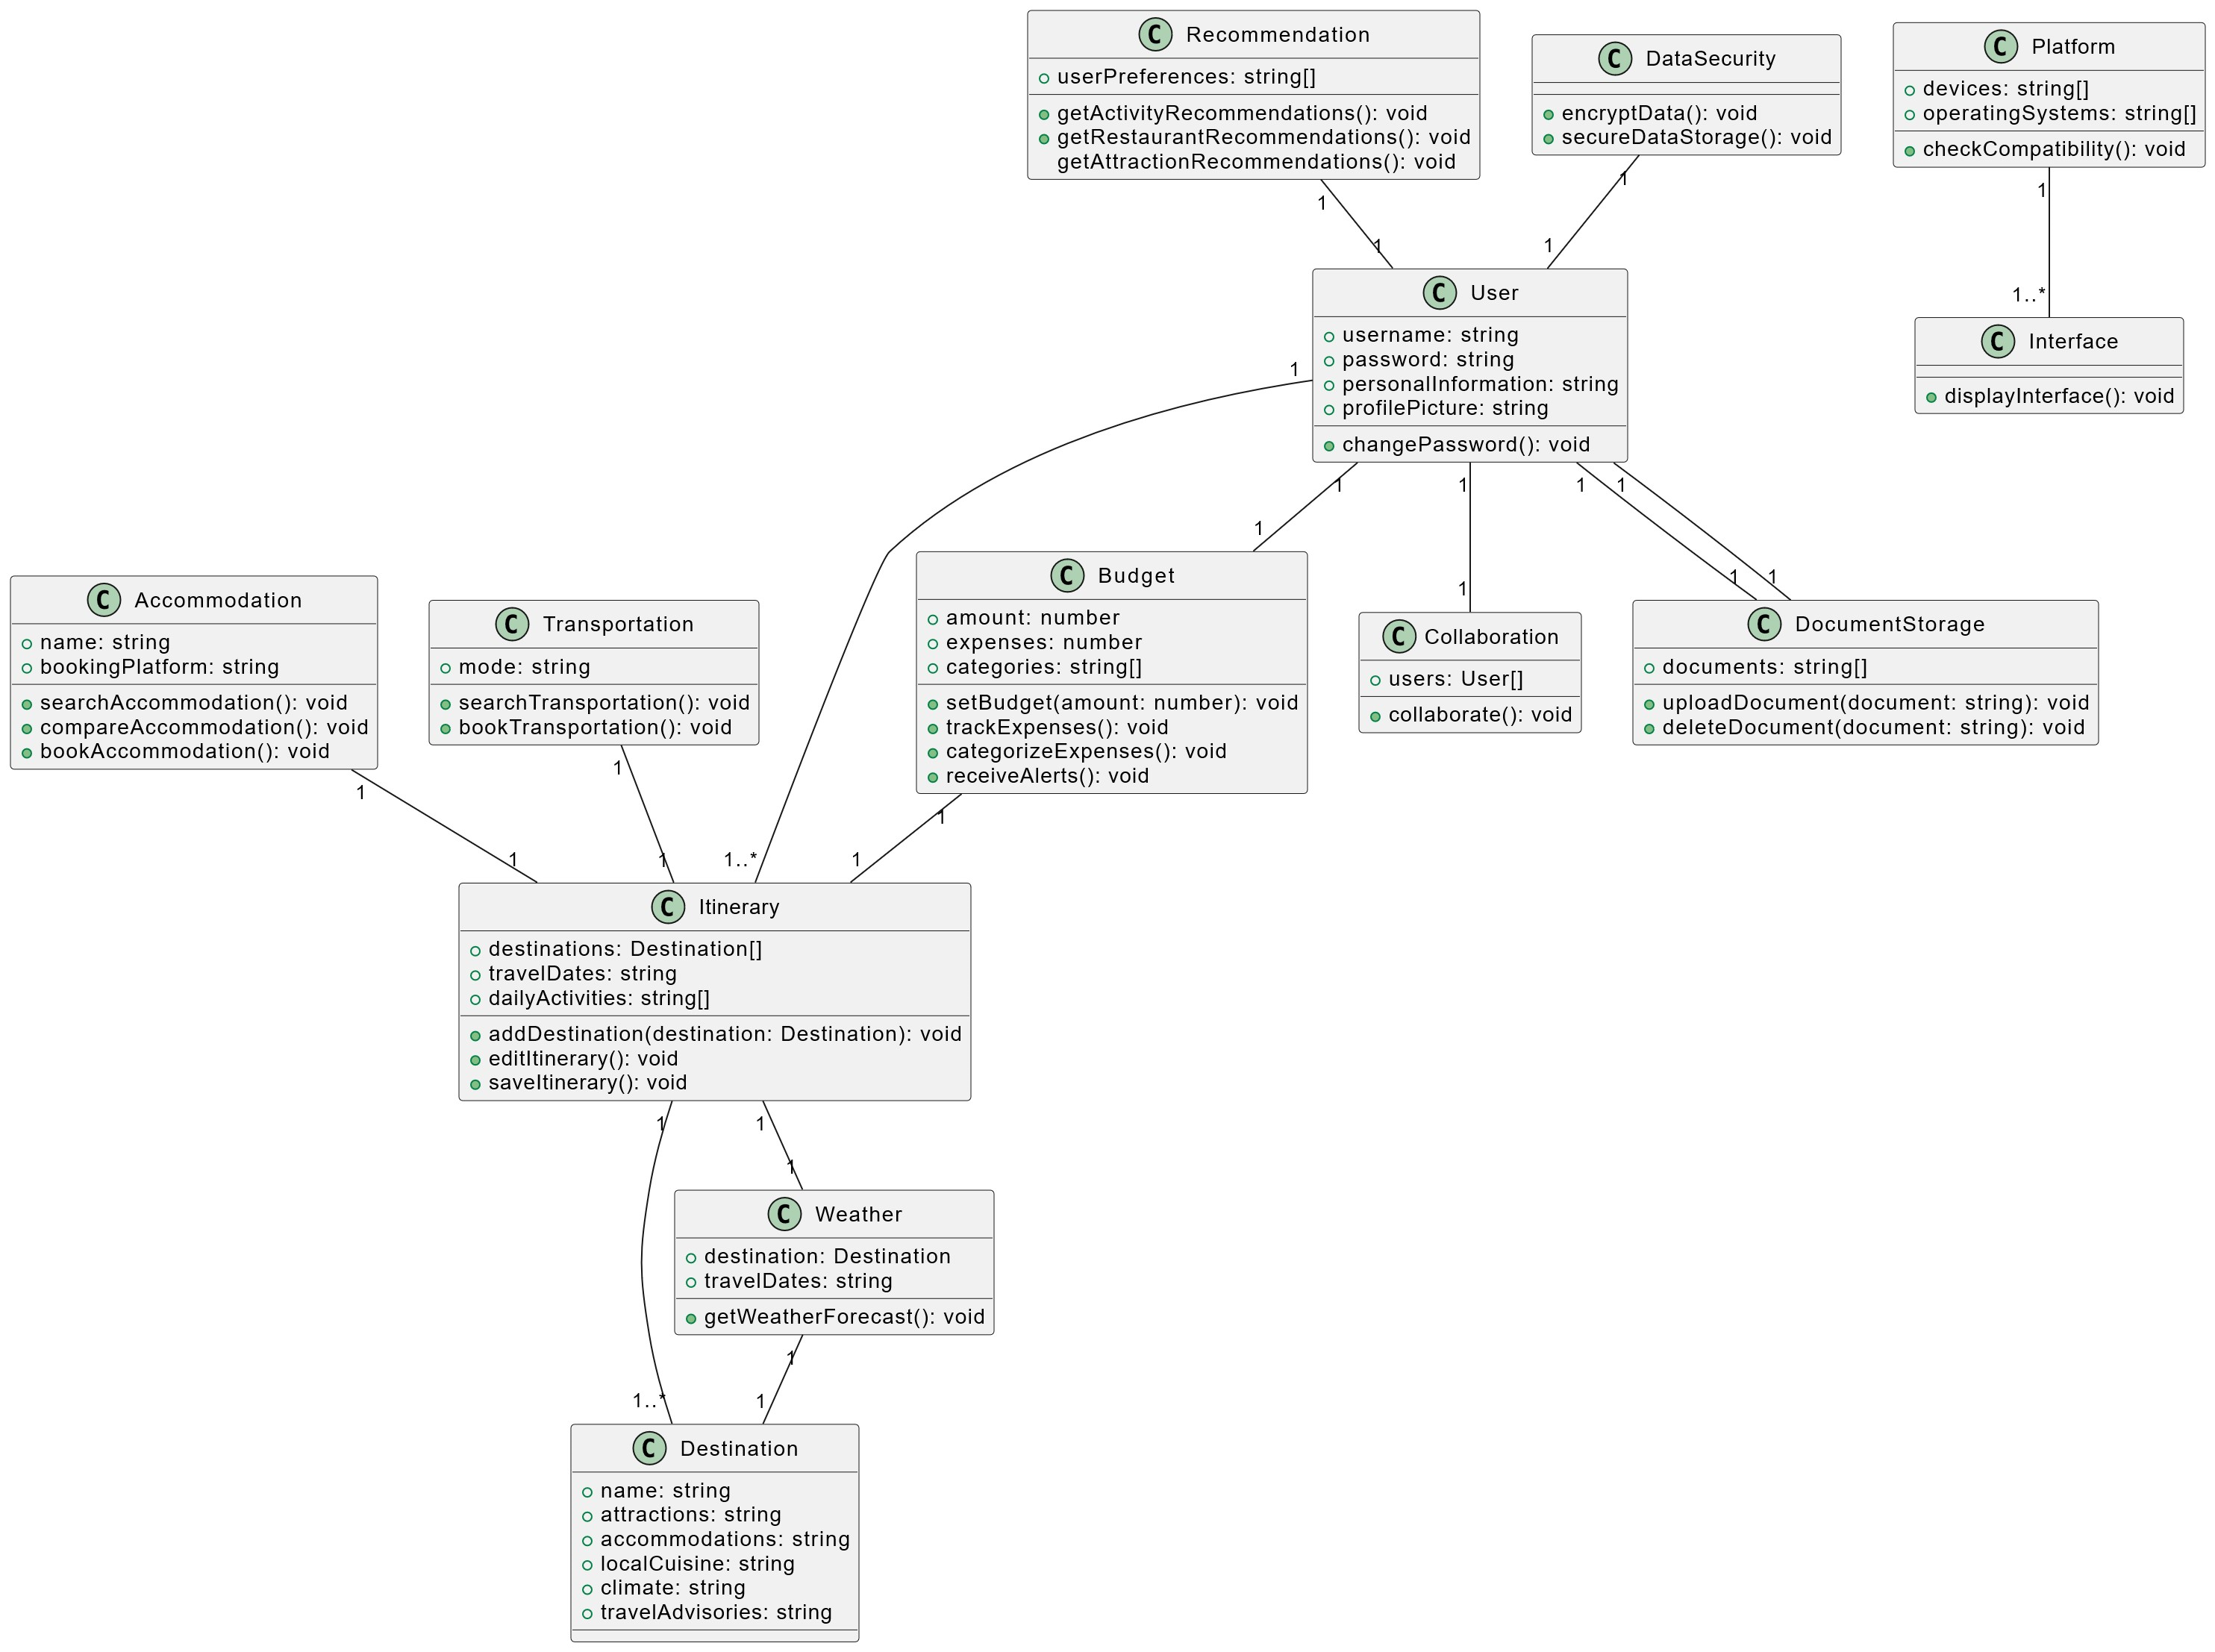

Figure 9 Class diagram

##### ****Process Designs:****

The processes within our system are intricately designed to orchestrate the flow of information and actions. Utilizing UML 2.x standards, we model the processes that govern the application logic, system functionalities, and the interaction between various components. This includes business logic, data processing, and communication between the client, server, and middle tier. By adhering to standards, we ensure clarity and coherence in the depiction and implementation of these critical processes.

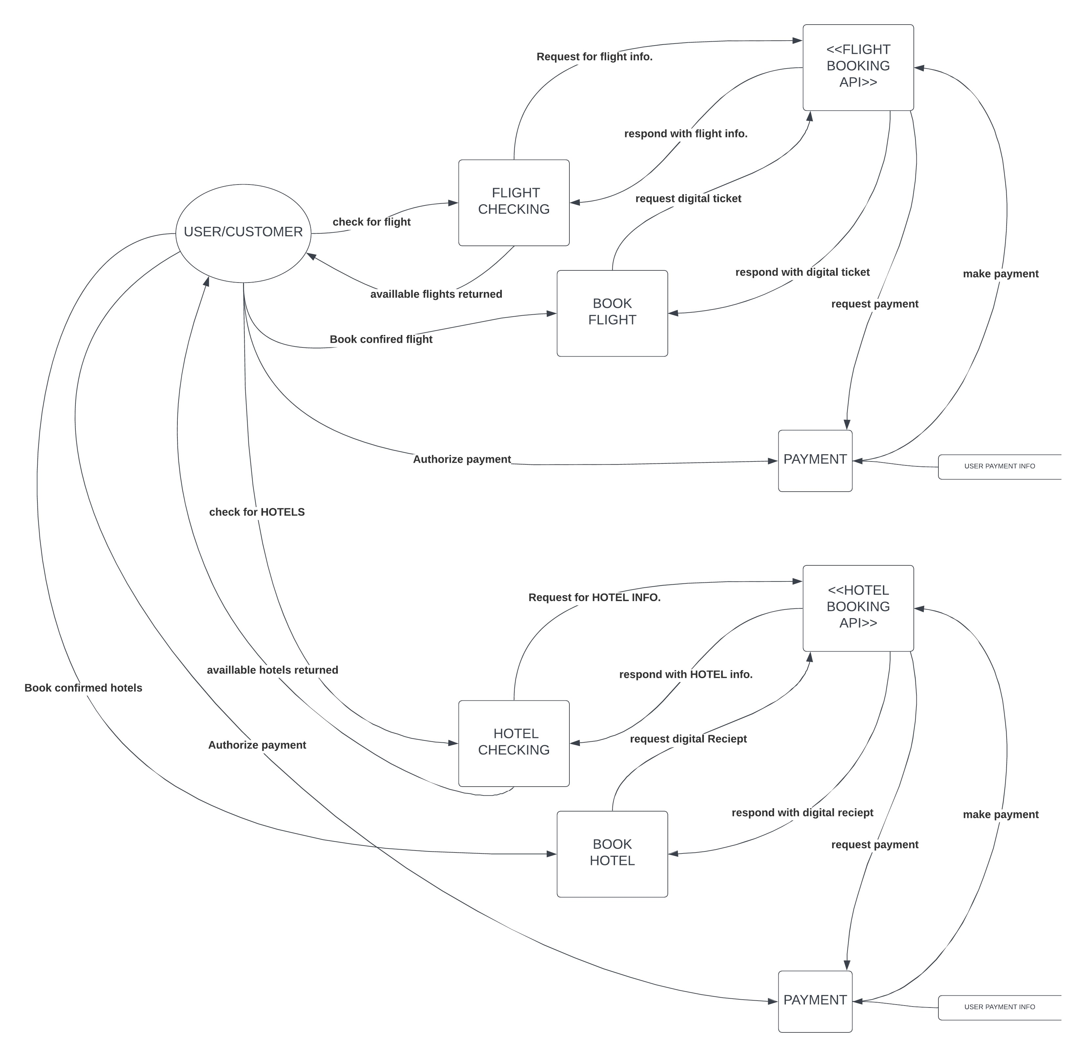

Figure 10 DFD Level 1 -flight and hotel booking diagram

## 4.2 System Architecture

### 4.2.1 Client/Server Architecture:

Our "Travel Planner and Itinerary Director" application follows a Client/Server architecture, structured as a web application. This architecture delineates clear roles for the client, server, and associated middle tier components.

**Client:**

* The client-side of our application primarily consists of web browsers. Users interact with the application through a user-friendly web interface delivered to their browsers.
* We prioritize a responsive and intuitive design to enhance user experience and accessibility across various devices and browsers.

**Server:**

* The server-side comprises distinct components for handling requests, processing logic, and managing data.
* Script servers execute server-side scripts, managing business logic and interactions between the client and the database.
* Database servers store and retrieve data, ensuring data integrity and reliability.

**Middle Tier:**

* The middle tier acts as a bridge between the client and server, facilitating communication and data transfer.
* It encompasses business logic, ensuring that data flows seamlessly between the client and the database.
* The middle tier is crucial for processing user inputs, executing application logic, and delivering dynamic content to the client.

### 4.2.2 N-tier Design:

Our application adopts an N-tier design, distributing functionality across well-defined tiers to enhance modularity, maintainability, and scalability.

**User Interface (UI) Tier:**

* The UI tier is responsible for presenting information to users and capturing their inputs.
* It includes HTML, CSS, and JavaScript components to create an interactive and visually appealing user interface.

**Business Logic (Application) Tier:**

* The business logic tier encapsulates the application's core functionalities.
* It processes user inputs, executes application logic, and communicates with the data tier for data retrieval and storage.
* This tier ensures the separation of concerns, making the application modular and easier to maintain.

**Data (Persistence) Tier:**

* The data tier manages data storage, retrieval, and integrity.
* It includes the database server and associated components that interact with the application's business logic tier.
* Database technologies and query languages are employed to store and retrieve data efficiently.

### 4.2.3 Other Considerations:

* **Security Measures:**
  + Our architecture integrates robust security measures, including encryption protocols, secure user authentication, and authorization mechanisms.
* **Scalability and Performance:**
  + The architecture is designed with scalability in mind, incorporating load balancing and performance optimization strategies.
* **Technology Stack:**
  + We utilize a modern technology stack, with React for the frontend, Node.js for the backend, and a relational database management system (RDBMS) for data storage

# **CHAPTER 5. CONCLUSIONS AND RECOMMENDATIONS**

## 5.1 Conclusions

The development journey of the "Travel Planner and Itinerary Director" project has been a compelling exploration into the realms of travel technology, user experience, and system integration. As we conclude this endeavor, several key observations and outcomes emerge:

1. **Enhanced User Experience:**

The project successfully addresses the complexity and challenges of travel planning, offering a seamless and user-friendly experience. The comprehensive suite of features, from itinerary creation to real-time weather updates, aims to elevate the user's journey from planning to execution.

2. **Holistic Approach to Travel Planning**:

Our platform fills a significant void in the market by providing a unified solution that integrates various aspects of travel planning. The inclusion of user collaboration, budget tracking, and secure document storage adds a holistic dimension to the travel planning experience.

3.**Technological Innovation:**

The project leverages modern technologies such as interactive maps, real-time data integration, and machine learning algorithms. This not only aligns with industry trends but also sets a new standard for user-centric travel planning solutions, blending innovation with practicality.

4. **Potential for Economic Impact:**

By facilitating travel, the project holds the potential to contribute to the economic development of various destinations, particularly those less explored by tourists. This can lead to job creation, infrastructure development, and increased visibility for local businesses.

5. **Valuable Insights for Stakeholders:**

The data generated by the platform, including travel trends and user preferences, presents a valuable resource for businesses and policymakers in the travel and tourism sector. These insights can inform strategic decisions, marketing efforts, and destination promotion initiatives.

## 5.2 Recommendations

Building on the project's successes and insights gained during the development process, the following recommendations are proposed for future enhancements and optimizations:

1.**Continuous User Feedback:**

Establish a mechanism for ongoing user feedback to monitor the platform's performance, identify pain points, and gather insights for future improvements. Regular surveys, user forums, or in-app feedback features can facilitate this process.

2. **Expansion of Destination Information:**

Continuously update and expand the destination information database to encompass a broader range of locales. Collaborate with tourism boards, local experts, and users to enhance the richness and accuracy of destination details.

3. **Integration of Augmented Reality (AR):**

- Explore the integration of augmented reality features to provide users with immersive experiences, such as virtual tours, interactive maps, and on-site information. This can further enhance the user's pre-travel exploration and on-location experiences.

4. **Partnerships with Travel Service Providers:**

- Form partnerships with accommodation providers, transportation services, and other travel-related businesses. Integrating seamless booking options directly within the platform can enhance user convenience and foster collaborations within the travel industry.

5. **Accessibility and Inclusivity Features:**

- Prioritize the development of accessibility features to ensure that the platform is inclusive and usable by individuals with diverse abilities. This includes features such as screen reader compatibility, color contrast adjustments, and text size customization.

6. **Cybersecurity Measures:**

Enhance cybersecurity measures to safeguard user data and maintain trust in the platform. Regular security audits, encryption protocols, and user education on cybersecurity best practices are critical components of this recommendation.

7.**Global Language Support:**

Extend language support to cater to a diverse user base. Implementing multilingual functionalities ensures that users from different regions can access and benefit from the platform in their preferred languages.

## 5.3 References

**Books:**

1. de Botton, A. (Year). The Art of Travel. Publisher.
2. Cohn, M. (Year). Agile Estimating and Planning. Publisher.
3. Rosenfeld, L., Morville, P., & Arango, J. (Year). Information Architecture: For the Web and Beyond. Publisher.

**Websites:**

1. W3Schools. (Year). "W3Schools - Online Web Tutorials." <https://www.w3schools.com/>
2. Google Developers. (Year). "Google Maps Platform Documentation." <https://developers.google.com/maps/documentation>
3. Stack Overflow. (Year). "Stack Overflow - Where Developers Learn, Share, & Build Careers." <https://stackoverflow.com/>
4. Project Management Institute (PMI). (Year). "Agile Practice Guide." <https://www.pmi.org/pmbok-guide-standards/>
5. World Travel & Tourism Council (WTTC). (Year). "World Travel & Tourism Council - The Authority on World Travel & Tourism." <https://www.wttc.org/>

## 5.4 Appendices

Appendix A: Questionnaire for Data Collection ([link](https://forms.gle/XN2vbocQS7C15CdP6))